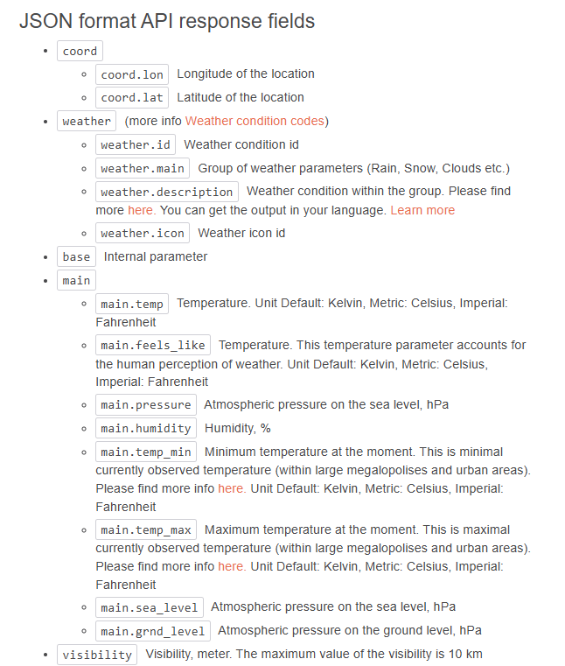

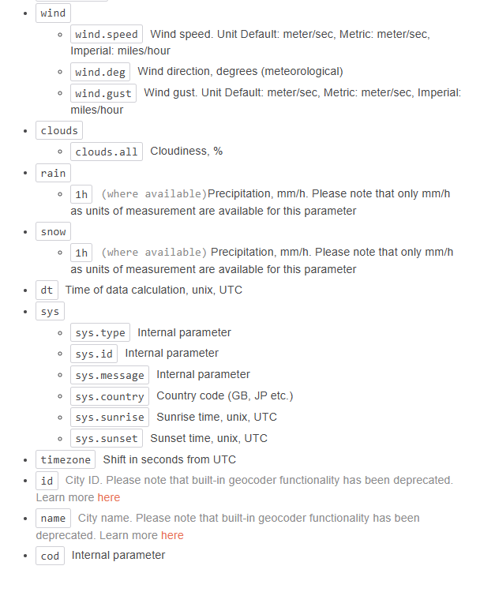

**JSON format API response example**

{

"coord": {

"lon": 7.367,

"lat": 45.133

},

"weather": [

{

"id": 501,

"main": "Rain",

"description": "moderate rain",

"icon": "10d"

}

],

"base": "stations",

"main": {

"temp": 284.2,

"feels_like": 282.93,

"temp_min": 283.06,

"temp_max": 286.82,

"pressure": 1021,

"humidity": 60,

"sea_level": 1021,

"grnd_level": 910

},

"visibility": 10000,

"wind": {

"speed": 4.09,

"deg": 121,

"gust": 3.47

},

"rain": {

"1h": 2.73

},

"clouds": {

"all": 83

},

"dt": 1726660758,

"sys": {

"type": 1,

"id": 6736,

"country": "IT",

"sunrise": 1726636384,

"sunset": 1726680975

},

"timezone": 7200,

"id": 3165523,

"name": "Province of Turin",

"cod": 200

}